OUTLINE

- INTRODUCTION
- PROJECT MANAGEMENT PLAN
- OVERALL DESCRIPTION
- FUNCTIONAL REQUIREMENTS
- NON-FUNCTIONAL/QUALITY REQUIREMENTS
- USER INTERFACE
- CONCLUSION
- REFERENCES
- APPENDIX

- INTRODUCTION
A real estate search portal is a website that allows users to find and contact the owners of the properties they are interested in. The portal aims to provide a convenient, fast, secure and easy-to-use service for both local and foreign customers. In this report, we will present the design and development process of a real estate search portal, as well as the content, target audience, competitive situation, legal obligations and revenue model of the portal. We will also explain the features and functions of the portal, such as language options, advanced search filters, sorting options, map view, comparison feature, adding to favorites, contact form, comment and rating, social media sharing and content creation. This report is based on the knowledge and skills in topics such as web design, database management, search engine optimization and security protocols. The purpose of this report is to summarize the issues we pay attention to in making a user-friendly, fast, secure and easily accessible real estate search portal.
Some of the benefits of having a real estate search portal are:
- Increasing Visibility: The portal will increase the visibility of the properties and the advertisers on the internet, reaching a wider and more diverse audience. The portal will also use search engine optimization techniques to rank higher on the search results and attract more traffic.
- Easy Accessibility: The portal will be accessible from any device, such as desktop, laptop, tablet or smartphone, and from any location, such as home, office or abroad. The portal will also have multiple language options, such as Turkish, English, Persian, Russian, German and Arabic, to cater to the needs of different customers.
- Effective Communication: The portal will enable effective communication between the users and the advertisers, by providing contact forms, phone numbers, e-mail addresses and social media links. The portal will also allow users to comment and rate the advertisements, as well as share them on social media platforms, creating a feedback loop and a sense of community.
- Access to Market Data: The portal will provide access to market data, such as price trends, supply and demand, location analysis and customer preferences, to help the users and the advertisers make informed decisions. The portal will also display the latest news and updates related to the real estate sector, keeping the users and the advertisers updated on the current situation and opportunities.
- Cost Effective: The portal will be cost effective for both the users and the advertisers, as it will reduce the need for intermediaries, such as brokers, agents and consultants, and save time and money. The portal will also offer various payment options, such as credit card, bank transfer, PayPal and Bitcoin, to facilitate the transactions. The portal will also generate revenue from various sources, such as advertisement fees, commission fees, subscription fees and premium features.

- PROJECT MANAGEMENT PLAN
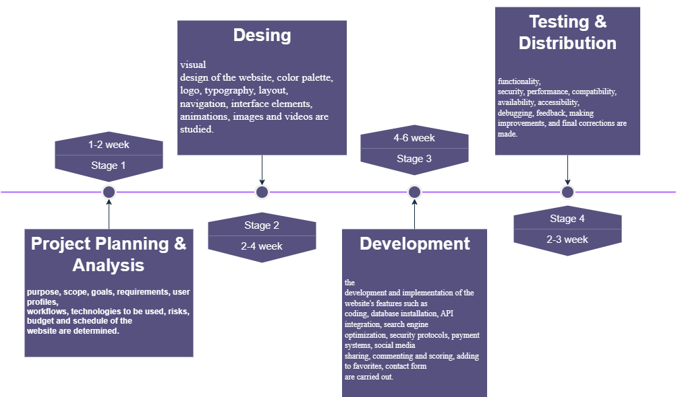
Timeline:

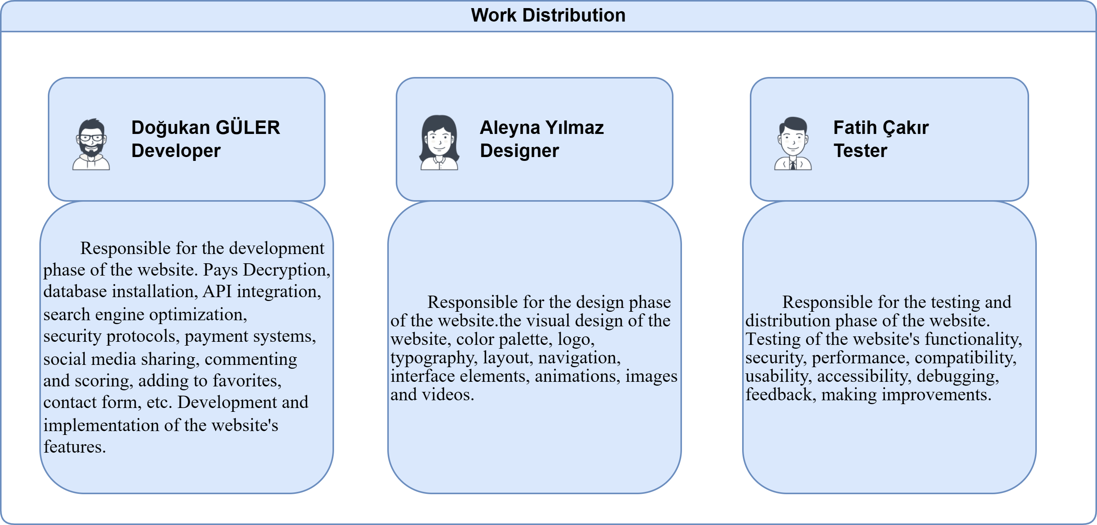
Work Distribution:
- INFORMATION COLLECTION METHOD, INTERVIEWS & RESERCH

Information collection method:
Data collection methods should be used to determine issues such as the purpose, scope, goals, requirements, user profiles, workflows, technologies to be used, risks, budget and schedule of the website. For example, experiments can be used to test the usability of the website, surveys can be used to understand whether the website is suitable for the needs of users, observations can be used to monitor the design process of the website.

Interviews:
During the design, development and testing stages of the website, interviews should be conducted with the owners, developers, testers and potential users of the website. These interviews can be used to measure whether the website is meeting expectations, the strengths and weaknesses of the website, the points where the website needs to be improved, the user experience and satisfaction of the website.

Researches:
During the design, development and testing stages of the website, research should be conducted on the competitors, Sunday, trends, opportunities and threats of the website. These researches can help the website to gain a competitive advantage, meet Sunday needs, develop new ideas and prevent potential risks. Research can be carried out by using various sources such as the Internet, books, articles, reports, statistics, databases. The reliability, timeliness and accuracy of the researches should be checked.

- ANALYSIS OF SOME SIMILAR SYSTEMS
In this section, the following websites are examined.
Zillow
Realtor
Trulia
Apartments
-Lack of sufficient listing:
Websites should offer a sufficient number and variety of listings so that users can easily find real estate with the features they are interested in. If websites are running with low inventory or outdated listings, this may cause users to move away from the website and turn to competing sites.
-High cost and low conversion ads:
Websites have had to advertise on platforms like Zillow to attract potential customers. However, the cost of these ads may be high and the conversion rate may be low. This can also reduce the profitability of websites.
-Website design, functionality and security:
Websites must have high standards in terms of design, functionality and security in order to attract users, provide them with an easy and enjoyable experience and convert them into loyal customers. Websites should have a visually attractive, simple, understandable and functional design, be mobile compatible, fast, secure and accessible, provide features that allow users to easily find the real estate they are looking for, get detailed information, contact advertising owners, add ads to favorites, make comments and ratings. Websites should conduct continuous testing and improvement on design, functionality and security.

- UML
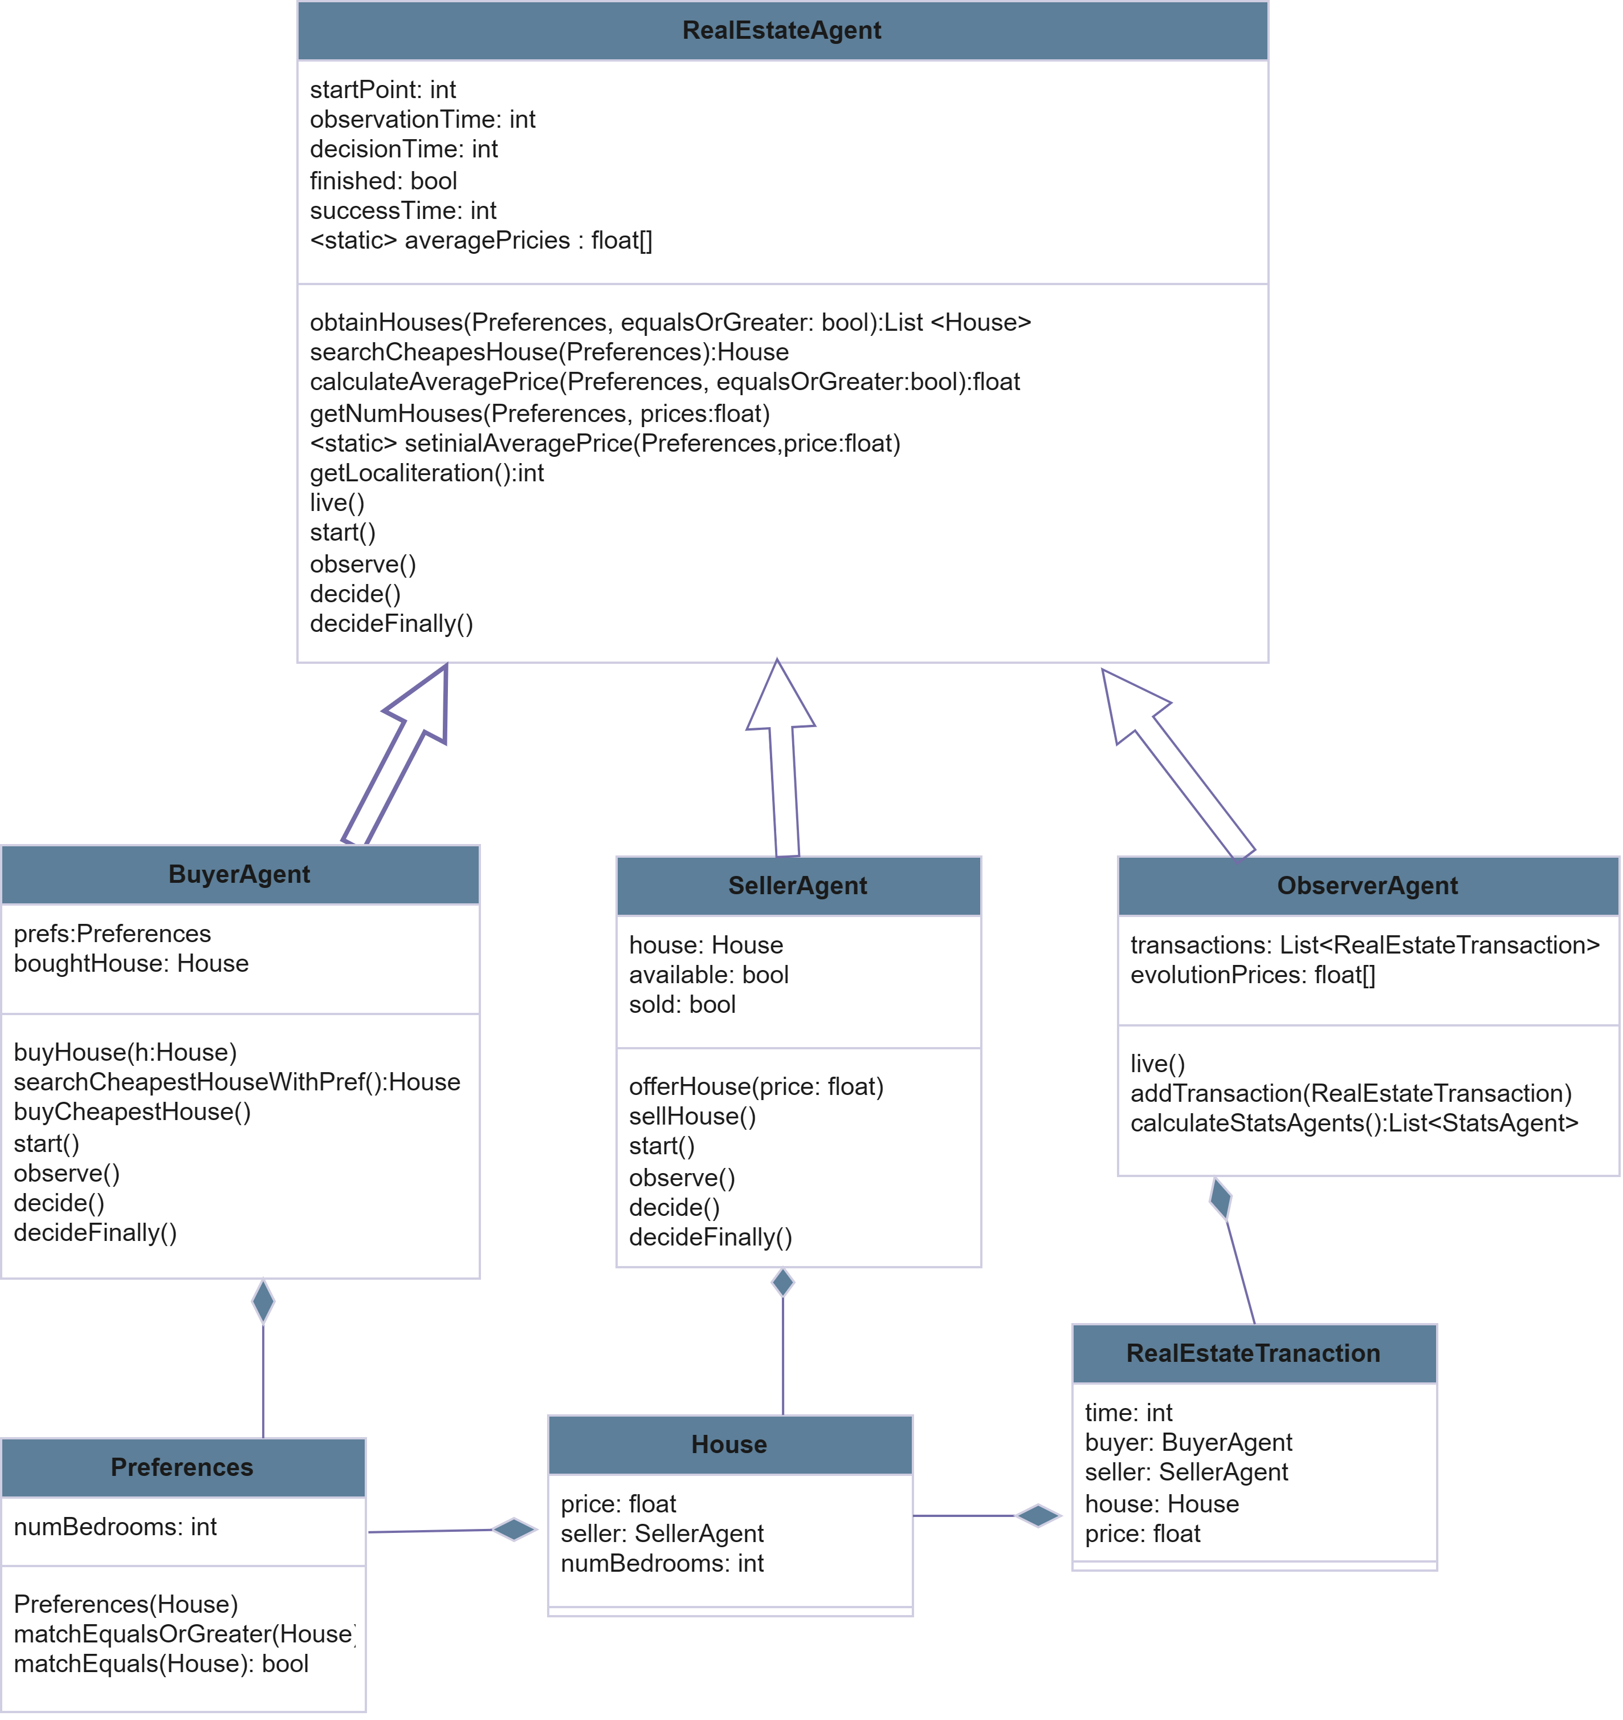

- CONCLUSION
This report is a summary of the issues we pay attention to in making a real estate agent web application. In this report, we presented the design and development process of a real estate agent web application, as well as the content, target audience, competitive situation, legal obligations and revenue model of the web site. We also explained the features and functions of the web site, such as language options, advanced search filters, sorting options, map view, comparison feature, adding to favorites, contact form, comment and rating, social media sharing and content creation. This report is based on the knowledge and skills in topics such as web design, database management, search engine optimization and security protocols.
The purpose of this report is to provide a comprehensive and informative guide for making a user-friendly, fast, secure and easily accessible real estate agent web application. As a web developer, we need to understand the needs and expectations of our clients, as well as the market conditions and trends. We need to communicate effectively with our clients, listen to their feedback, and deliver the best possible solution for their problems. We need to use the latest technologies and tools to create a high-quality and high-performance web site that meets the standards and requirements of the real estate sector. We need to test and improve our web site continuously, and ensure its security and reliability. We need to create a competitive advantage for our web site, and provide value and satisfaction for our users.
A real estate agent web application is a valuable and profitable project that can benefit both real estate agents and customers. A real estate agent web application can increase the visibility, accessibility and communication of the real estate agents, and provide them with access to market data and cost-effective advertising. A real estate agent web application can also provide the customers with a convenient, fast, secure and easy-to-use service that can help them find and contact the properties they are interested in. A real estate agent web application can also create a sense of community and trust among the users, and enhance their experience and loyalty. A real estate agent web application can also contribute to the development and innovation of the real estate sector, and create new opportunities and challenges.

- REFERENCES
- How to Build a Real Estate App I Real Estate App Development Guide (ascendixtech.com)
- Real Estate Web Application - Echopx Technologies | Website design & Development | SEO Company
- Software Requirements Analysis with Example (guru99.com)
- Sharma Tushar (2012-2013) / A Project Report On “REAL ESTATE LISTING WEB APPLICATION” / Roll No. 91133313 / Enrollment No. SGVU091133313
- RASHI CHOPRA / REAL ESTATE WEB APPLICATION / B.E., Medicaps Institute of Technology and Management, India, 2006 / KANSAS STATE UNIVERSITY / Manhattan, Kansas 2008
- 19 Problems of Being in a Real Estate Industry [With Solutions] (salesmate.io)
- Data Collection | Definition, Methods & Examples (scribbr.com)
- Real Estate Web Development | inMotion Real Estate Media
- Zillow: Real Estate, Apartments, Mortgages & Home Values
- realtor.com® | Homes for Sale, Apartments & Houses for Rent
- Trulia: Real Estate Listings, Homes for Sale, Housing Data
- Apartments and Houses for Rent | realtor.com®

4.FUNCTIONAL REQUIREMENTS
  - User Requirements
REQ-1: Users can register and log in.
REQ-2: Users can manage their account (adding profile photo, editing personal information, etc.).
REQ-3: Users can reset or update their passwords.
REQ-4: Users can use two-factor authentication (Mobile phone, email verification).
REQ-5: Users can have the authority to review other users’ profiles.
REQ-6: Users can delete their accounts and their data if they want.
    - Buyer Requirements
REQ-1: Buyer can search for properties and narrow down results with various filtering options.
REQ-2: Buyer can add properties they like to favorite and access them easily later.
REQ-3: The buyer can pay using secure payment methods.
    - Seller Requirements
REQ-1: The seller can create a property listing and enter relevant information (location, price, number of rooms, etc.).
REQ-2: The seller can edit or delete existing listings.
REQ-3: The seller can review the statistics for listings (number of views, added to favorites, etc.).
REQ-4: The seller can start the sale transaction and receive payment.
REQ-5: The sellers can display their properties on the location.

    - Admin Requirements
REQ-1: The admin can create, edit, or close new or current user accounts.
REQ-2: The admin can filter or delete inappropriate content.
REQ-3: The admin can display and analyze general system statistics.
REQ-4: The admin can reach database and display user data.
REQ-5: The admin can check system backup operations.

- NONFUNCTIONAL/QUALITY REQUIREMENTS
  - System Requirements
- The website should load quickly.
- The website should be open and accessible 24/7.
  - Security Requirements
- The website should have an SSL certificate and protect the data of users.
- The website should have a firewall which provides protection from DDoS attacks.
  - Usability Requirements
- The website should have a user-friendly interface.
- The website should work properly on the mobile platform, as well.
- The website should have a live support assistant which 24/7 open.
  - Compatibility Requirements
- The website should be compatible with different internet browsers and devices.
  - Maintenance:
- The system should update and maintain the website regularly.
- The system should backup system data and being recoverable regularly.

